

Magenuts IT Solutions Pvt Ltd.

Magento 2 Portfolio Extension

CONFIGURATION AND SETUP MANUAL

TABLE OF CONTENTS

What’s Magento 2 Portfolio…………………….................................................................................................3

Installation .................................................................................................................................................4

Portfolio Category Grid................................................................................................................................5

Add / Edit Category .....................................................................................................................................6

Portfolio List Grid ........................................................................................................................................7

Add Portfolio Item…………………………….........................................................................................................8

Frontend Portfolio Listing Page...................................................................................................................9

Frontend Portfolio Detail Page .................................................................................................................10

Support And Customization …………………..................................................................................................11

**What’s Magento 2 Portfolio?**

Magenuts Portfolio Magento 2 extension helps you to showcase your services, and work on your store easily. Grab the users attention with this extension and let your work speak for you. Magenuts Portfolio Extension for Magento 2 will help you to easily add and show your portfolio on your store. If you have the projects that use the products of your shop and you want to present it in your shop, you can use this extension to let your portfolio speak for you. This extension mostly used when you want to showcase the most satisfying services you completed to your customers/visitors.

Key Features

* Very easy to install even beginner can install and use it.
* Fully Responsive.
* Show your services to grow your business.
* Show your portfolio category wise.

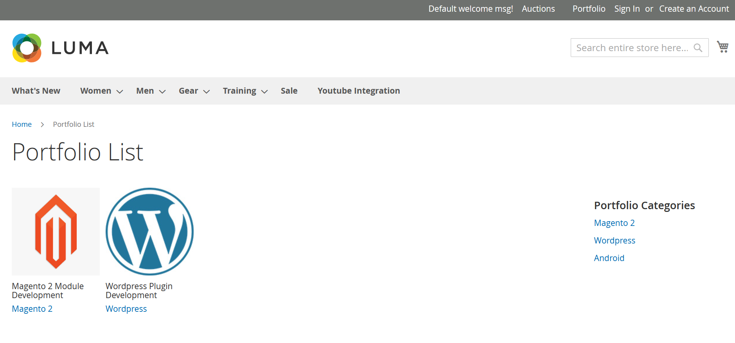

**Important Notes and Requirements**

1. Requirements: **Magento Community 2.1.x up-to 2.4.3, Magento Enterprises (2.1.x to latest).**
2. Server Side Requirements: MySQL 5.0 and above PHP 7.1.6 and above.
3. All functionality is fully tested on Magento Community Edition 2.2.2 and will be compatible withEditions from 2.1.x up to 2.4.3.
4. Magento Enterprises Edition is also supported but not tested.
5. For your safety related to any damage or loss to your store, its strongly recommended to you that take backup first.

**Installation**

1. Unpack the extension ZIP file on your computer.
2. Connect to your website source folder with FTP/SFTP/SSH client and upload all the files and folders from the extension package to the corresponding root folder of your Magento 2.x installation:

|  |
| --- |
| Please use the “**Merge**” upload mode. Do not replace the whole folders, but merge them. This way your FTP/SFTP client will only add new files. This mode is used by default by most of FTP/SFTP clients software. For MacOS it’s recommended to use Transmit. If you install several extensions from Amasty, they will contain same files from the Base package — feel free to overwrite them, these are system files used by all our extensions. |

1. Connect to your Magento directory with SSH.
2. Run the following 3 commands:
3. php bin/magento setup:upgrade
4. php bin/magento setup:static-content:deploy
5. php bin/magento setup:di:compile

**Portfolio Category Grid**

Click at Magenuts Menu in the admin panel and then click Portfolio Category as see in the following picture.

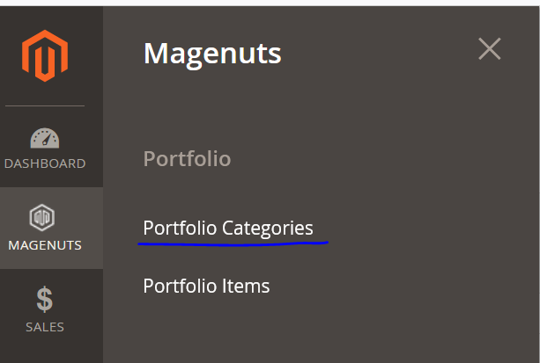

You will see Category List Grid

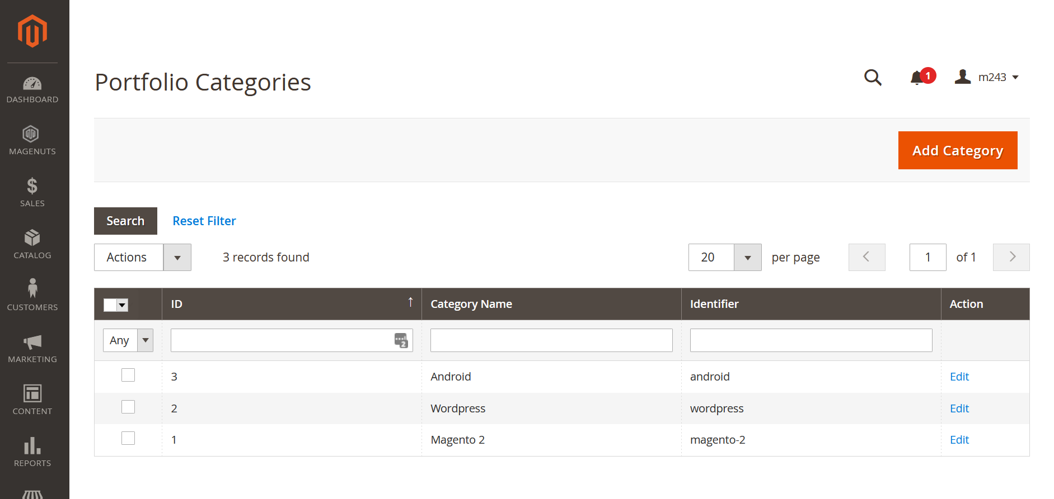

**Add / Edit Category**  
Click at the Add Category button to Add Portfolio Category as seen the following picture.

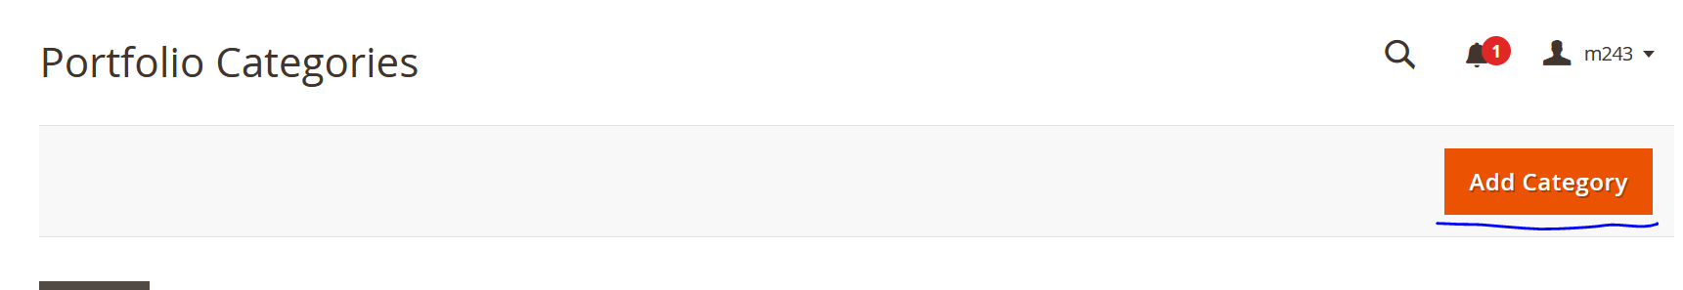

Fill the complete Form and Click at Save button as seen in the following picture.

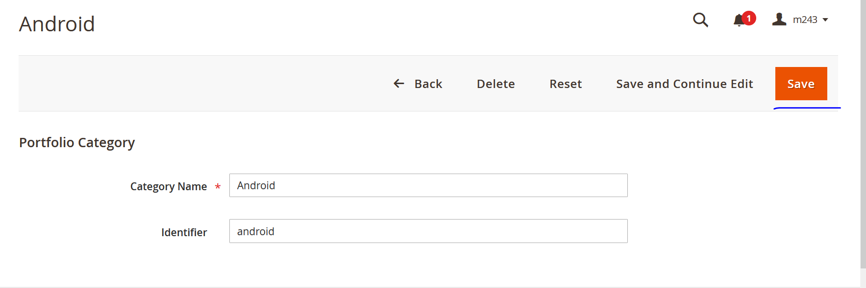

For Edit Category Click at Edit link in the Grid as seen in the following picture and save the form.



**Portfolio List Grid**

To see portfolio items in the grid Click on Magenuts and then Portfolio Item in admin panel menu as seen in the following picture.

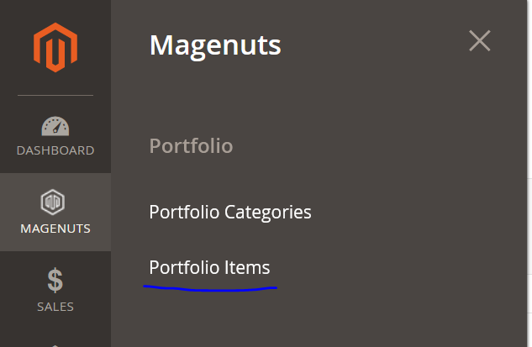

You will see the following grid.

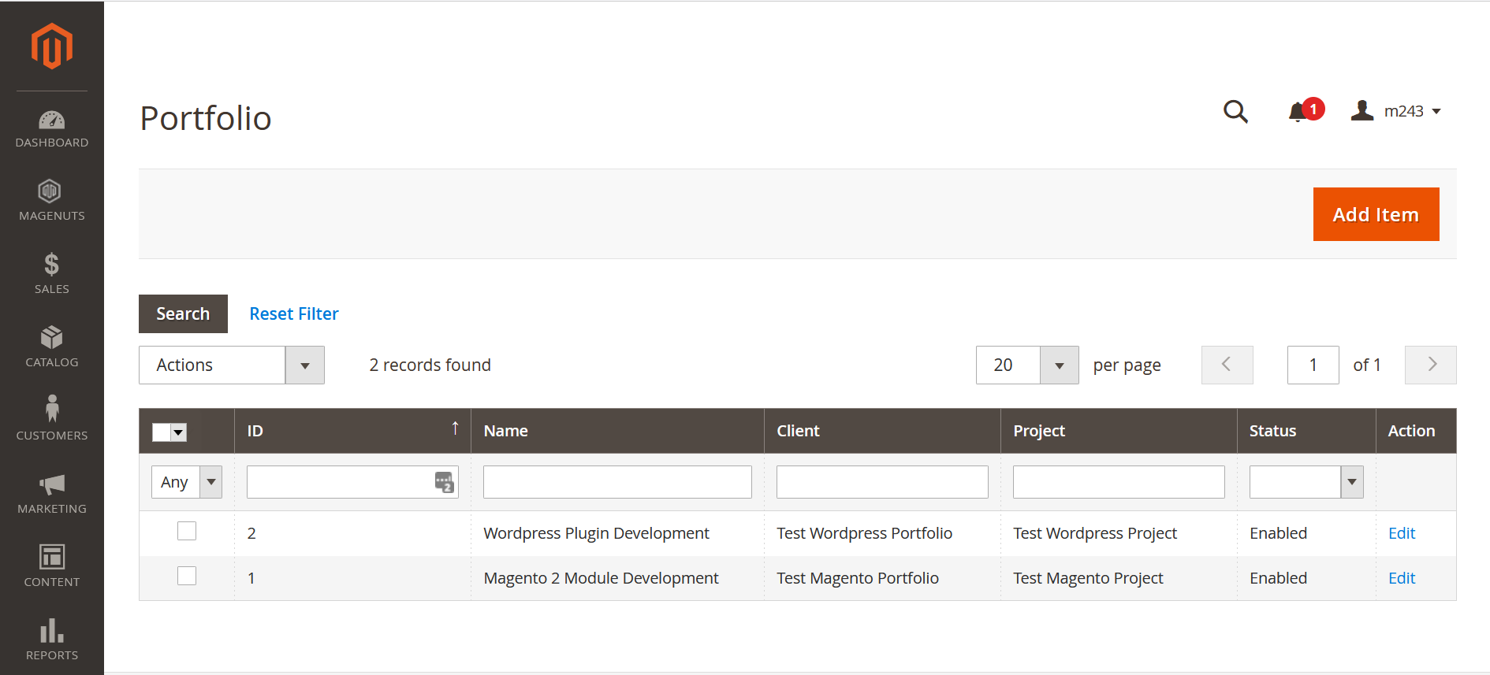

**Add Portfolio Item**

Click at the Add Item button as seen in the above picture you will see a form for portfolio item as seen in the following picture. Fill the form and click at the Save button.

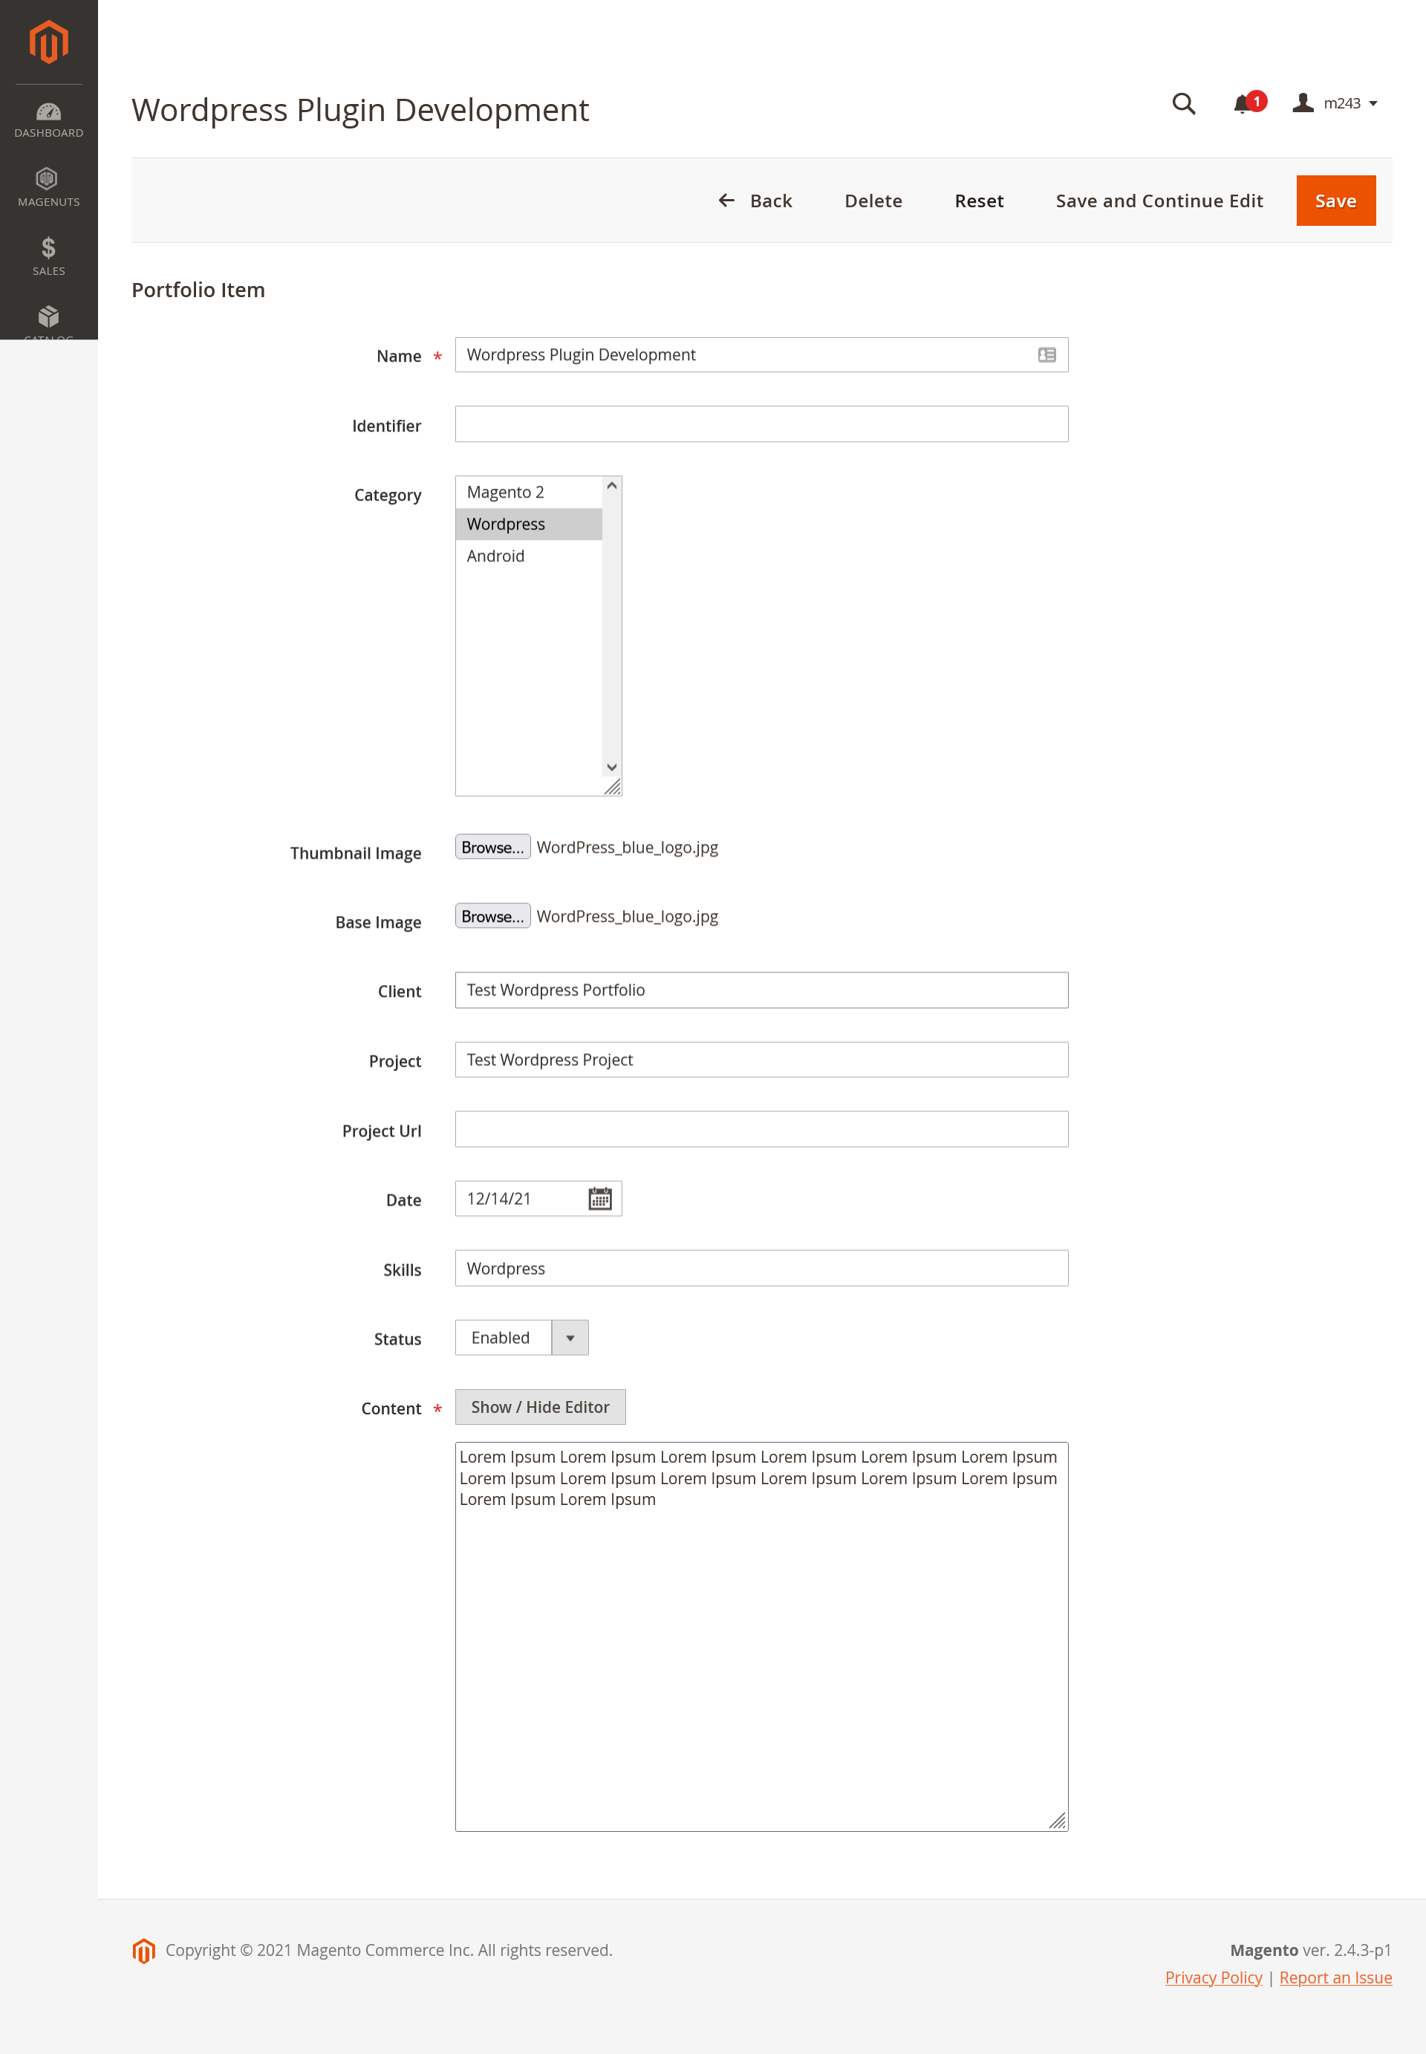

**Frontend Portfolio Listing Page**

Click at the Portfolio top link the see the portfolio as seen in the following picture.



**Frontend Portfolio Detail Page**

To see any Portfolio Item Detail click at any Portfolio seen in the above image you will see the portfolio detail as seen in the following picture.

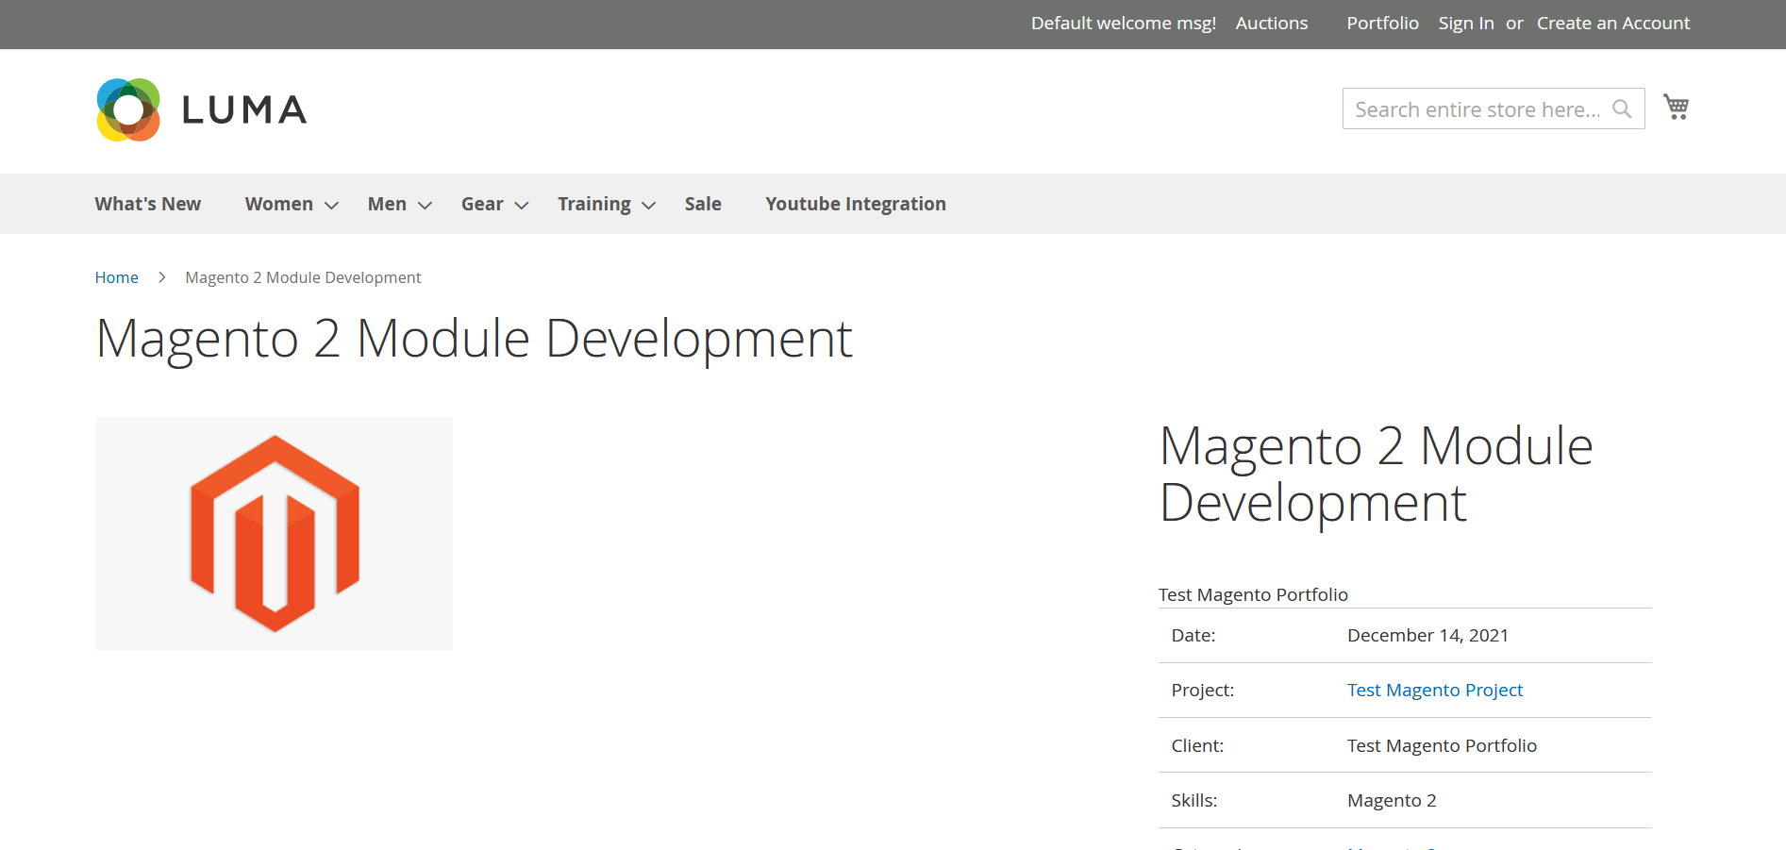

**Support and Customization**

For any support or customization, you can contact us

[support@magenuts.com](mailto:support@magenuts.com)

https://magenuts.com